Concise and informative title

- First Author Name, Affiliation, Email (mandatory for corresponding author), ORCID (optional)
- Second Author Name, Affiliation (if currently unaffiliated, please add city and country), Email (optional), ORCID (optional)
- ….

Abstract
Please provide an abstract of 150 to 250 words. The abstract should not contain any undefined abbreviations or unspecified references.

Keywords
Please provide 4 to 6 keywords which can be used for indexing purposes.

Statements and Declarations
Competing Interests: Authors are required to disclose financial or non-financial interests that are directly or indirectly related to the work submitted for publication. Please refer to “Competing Interests and Funding” below for more information on how to complete this section.
Please see the relevant sections in the submission guidelines for further information as well as various examples of wording. Please revise/customize the sample statements according to your own needs.

Acknowledgments
Acknowledgments of people, grants, funds, etc. should be placed in a separate section on the title page. The names of funding organizations should be written in full.

1. Please use the decimal system of headings with no more than three levels.
Manuscripts should be submitted in Word. Use a normal, plain font (e.g., 10-point Times Roman) for text. Use italics for emphasis. Use the automatic page numbering function to number the pages. Do not use field functions. Use tab stops or other commands for indents, not the space bar. Use the table function, not spreadsheets, to make tables. Use the equation editor or MathType for equations. Save your file in docx format (Word 2007 or higher) or doc format (older Word versions). See table 1.
 | Column A | Column B
Row 1 | Hello | World
Row 2 | World | Hello
Table 1: All tables are to be numbered using Arabic numerals. Tables should always be cited in text in consecutive numerical order. For each table, please supply a table caption (title) explaining the components of the table.

2. Artwork
For the best quality final product, it is highly recommended that you submit all of your artwork – photographs, line drawings, etc. – in an electronic format. Your art will then be produced to the highest standards with the greatest accuracy to detail. The published work will directly reflect the quality of the artwork provided. See figure 1.

2.1 Figure Numbering
- All figures are to be numbered using Arabic numerals.
- Figures should always be cited in text in consecutive numerical order.
- Figure parts should be denoted by lowercase letters (a, b, c, etc.).
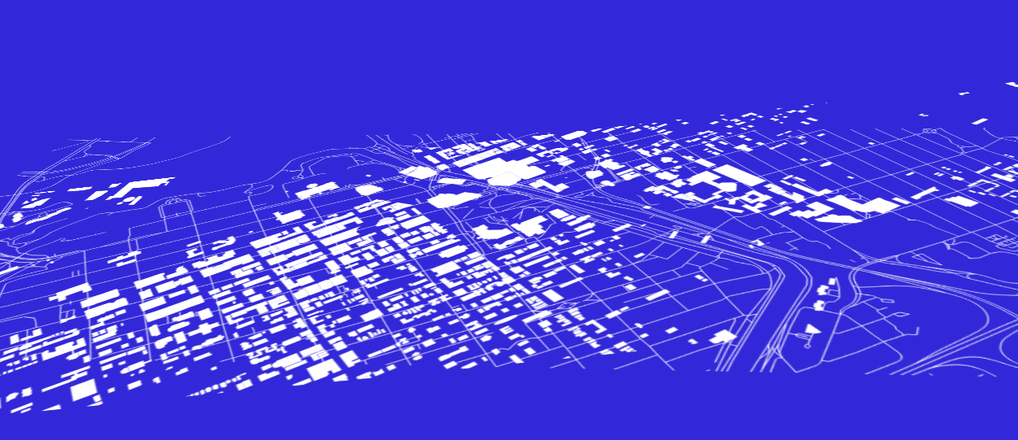
Fig 1 Each figure should have a concise caption describing accurately what the figure depicts. Include the captions in the text file of the manuscript, not in the figure file.

3. Citation
Cite references in the text by name and year in parentheses. Some examples:
- Negotiation research spans many disciplines (Thompson 1990).
- This result was later contradicted by Becker and Seligman (1996).
- This effect has been widely studied (Abbott 1991; Barakat et al. 1995a, b; Kelso and Smith 1998; Medvec et al. 1999, 2000).

Reference list
Gamelin FX, Baquet G, Berthoin S, Thevenet D, Nourry C, Nottin S, Bosquet L (2009) Effect of high intensity intermittent training on heart rate variability in prepubescent children. Eur J Appl Physiol 105:731-738. https://doi.org/10.1007/s00421-008-0955-8

Footnotes can be used to give additional information, which may include the citation of a reference included in the reference list. They should not consist solely of a reference citation, and they should never include the bibliographic details of a reference. They should also not contain any figures or tables.
Footnotes to the text are numbered consecutively; those to tables should be indicated by superscript lower-case letters (or asterisks for significance values and other statistical data). Footnotes to the title or the authors of the article are not given reference symbols.
Always use footnotes instead of endnotes.

